Microcontroller-Based MTPA for BLDC Motors with Large Inductance and Misaligned Hall Sensors

Mark Phung   
*Engineering Physics*  
*University of British Columbia*Vancouver, Canada

marklong@student.ubc.ca  
 Matthew Hasman  
*Engineering Physics*  
*University of British Columbia*Vancouver, Canada

matthas@student.ubc.ca  
Ziliang Feng   
*Electrical and Computer Engineering*  
*University of British Columbia*Vancouver, Canada

zlfen019@ece.ubc.ca  
Juri Jatskevich  
*Electrical and Computer Engineering*  
*University of British Columbia*Vancouver, Canada  
jurij@ece.ubc.ca

*Abstract*— Brushless DC (BLDC) motors with Hall-effect sensors are ubiquitous in industrial, robotics, and mobility applications due to their high efficiency, lower cost, and superior power density. A typical BLDC motor is driven by a voltage-source inverter (VSI) using the common six-step 120º commutation logic, where the Hall sensor signals estimate the rotor position at discrete intervals. However, Hall-sensor misalignment in many cost-effective BLDC motors leads to unbalanced phase currents and increased torque ripple. Additionally, BLDC motors with large winding time constants have prolonged phase current commutation period that deviates the system from optimal maximum torque-per-Ampere (MTPA) operation. This paper builds on previous research to propose a new method combining a Hall-sensor filter and dynamic MTPA PI controller for real-time correction of the advance firing angle. The proposed method is implemented on a modern microcontroller. Experimental results demonstrate significant improvement on a typical industrial BLDC motor with substantial Hall-sensor misalignment and large winding inductance.

Keywords—Brushless DC (BLDC) motor, firing angle, Hall-sensor misalignment, maximum torque-per-ampere (MTPA).

# Introduction

Brushless DC (BLDC) motors are widely used in many modern industries, such as electric mobility, robotics, and manufacturing, due to their reliability, higher power density, and superior efficiency [1]. In a typical low-cost BLDC motor drive, a permanent magnet synchronous machine (PMSM) is controlled by a voltage-source inverter (VSI) and Hall-effect sensors, as shown in Fig. 1. The phase currents are commutated electrically based on the rotor’s electrical angle estimated from the Hall sensor signals [2].

The six-step 120º commutation logic is widely adopted for industrial BLDC motors due to the simple controller implementation and the natural approximation of the so-called maximum torque-per-ampere (MTPA) operation [3]. In the 120º commutation, each power transistor conducts for a third of the electrical cycle, and the phase current is discontinuous [4]. It is typical to drive the motor in the common operating mode (COM), which directly uses the Hall sensor signals and aims to align the phase current’s fundamental component with the phase back EMF generated by the rotor’s permanent magnet, thus approximating the MTPA condition.

This research was supported by The Natural Sciences and Engineering Research Council of Canada (NSERC) under the Discovery Grant.

However, the fixed advance firing angle used in COM with the 120º commutation is not always effective due to practical challenges that include the Hall-sensor misalignment and large inductance (i.e. time constant) of the phase winding [6]-[7].

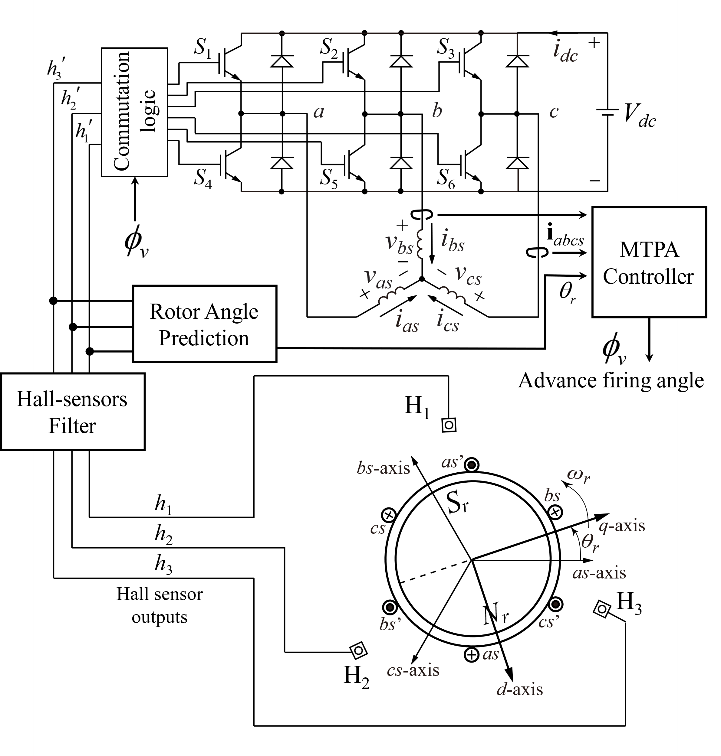

Fig. 1. A typical BLDC motor drive system with VSI and Hall sensors.

The intrinsic manufacturing mechanical tolerances shift the Hall sensors from their ideal locations, leading to uneven switching intervals, unbalanced phase currents, and higher torque ripple [8]. Previous research has proposed filtering methods for the Hall sensor signals, such as the running average filters [9]-[10], which do not address the increased deviation from the optimal MTPA condition due to the filter itself. In particular, the longer phase current commutation time in motors with a large time constant requires changing the advance firing angle depending on the operating point. For these machines, high-order filters and PI controllers have been proposed to recover the MTPA condition by correcting the advance firing angle [7], [11]-[12]. These methods, however, require stable rotor position prediction, which is impeded by Hall-sensor misalignment.

This paper proposes a practical method that is implementable on any modern microcontroller to resolve both Hall-sensor misalignment and deviation from MTPA due to large motor inductance (i.e., time constant). The control scheme includes an averaging filter with extrapolation acting simultaneously with an MTPA PI controller to maintain the balanced phase currents and maximize torque output in real-time for varying operating conditions. The microcontroller implementation is discussed in detail, and the proposed controller is validated experimentally using a typical industrial BLDC motor with considerable Hall-sensor misalignment and a large stator winding time constant (inductance).

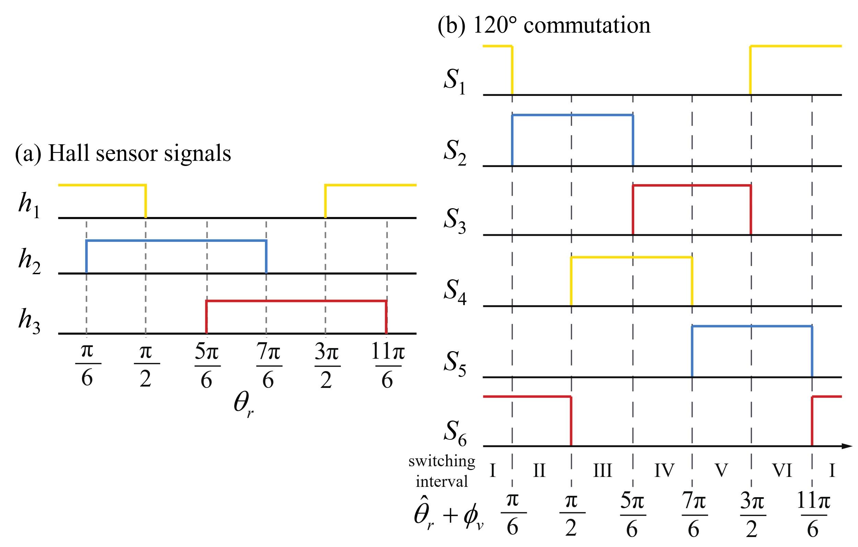

Fig. 2. (a) Conventional 180 $°$ Hall sensor signals and (b) the 120° commutation switching logic for BLDC motors.

# Modeling of BLDC Motor Drive System

The considered typical industrial BLDC motor drive system, as shown in Fig. 1, consists of a PMSM energized by VSI and Hall sensors for rotor angle estimation.

## Modeling of the PMSM

Following the work in [4] and [5], this paper also assumes that the PMSM has sinusoidal back EMF and round rotor (i.e. no saliency). The Park’s transformation is used to express all variables in the *qd*-rotor reference frame as



where the transformation matrix is given by



In (2), the rotor electrical position  is defined with respect to the *q*-axis. The voltage equations can then be written in the *qd*-frame [2] as





whereis the equivalent stator self-inductance. Similarly, the transformed back EMFs are given by

.

The electromagnetic torque  for a *P*-pole machine is as [2]



The mechanical dynamics are represented by a single rigid body with a total lumped inertia  and rotor electrical speed  expressed as

, and .

where is the total mechanical load torque, andis the rotor electrical speed.

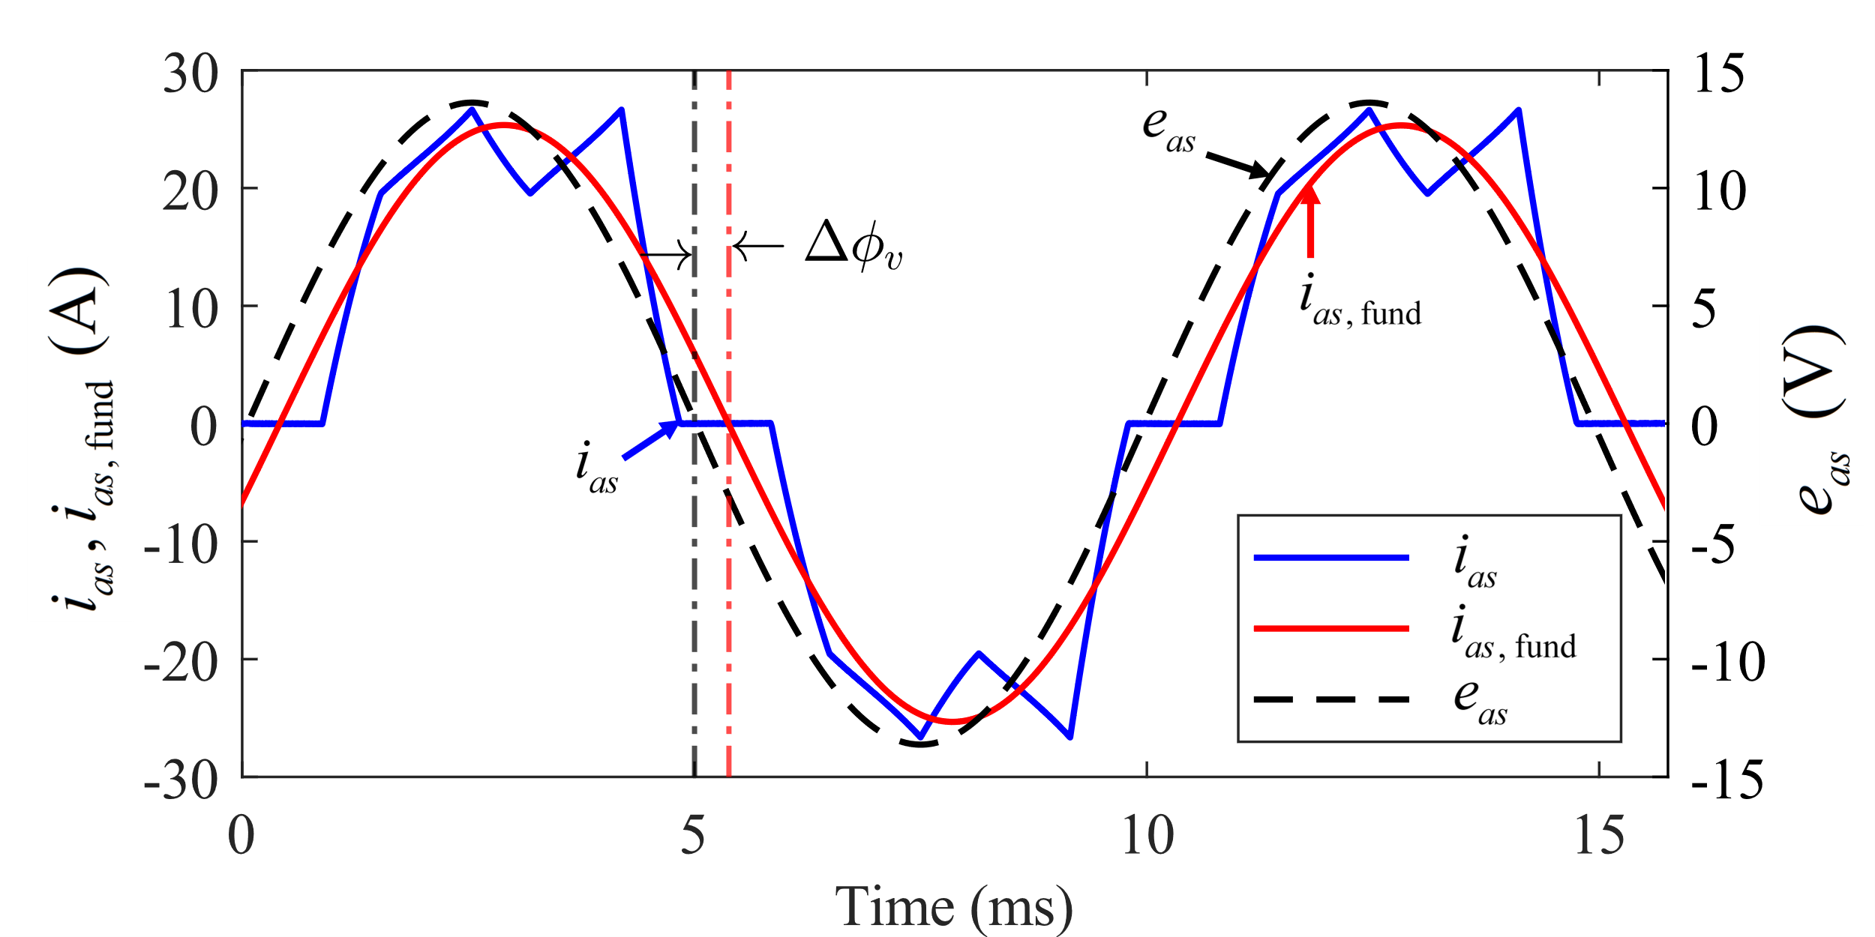

Fig. 3. Misalignment of the fundamental phase current and back EMF under 120° COM control for BLDC motor with a large winding time constant.

As seen in , for the round rotor machine, the *d*-axis current does not contribute to the output torque and thus generates losses. However, for the MTPA control, which aims to maximize the ratio of produced torque over the phase current magnitude, the current should be controlled to zero. To achieve MTPA in six-step operation with torque ripple, the time-average of the *d*-axis current evaluated over the switching interval denoted by is controlled to zero [7]. Also, since by the choice of reference frame, the MTPA is equivalent to aligning the phase currents to the back EMFs.

## Approximating MTPA in the 120º Commutation Logic

In the six-step 120º commutation logic, the six transistors in Fig. 1 are operated according to the sequence depicted in Fig. 2, determined by the estimated rotor electrical angle and the advance firing angleEven though the fixedin COM approximates MTPA satisfactorily for motors with small winding time constant [7], the mismatch of phase current and back EMF worsens for high-performance machines with large inductance. As shown in Fig. 3, for a generic BLDC with a large stator winding time constant, the advance firing angle must be compensated by angleto recover the MTPA condition. Moreover, sincegenerally depends on the machine parameters and the operating condition, [7] previously proposed a dynamic PI controller to determineby regulatingHowever, this method works poorly under Hall-sensor misalignment that leads to higher phase current distortion and inaccurate rotor position estimation.

## Impact of Hall Sensors Misalignment

The misalignment of Hall sensors from their ideal positions leads to deviation of the switching instances away from their designated timings shown in Fig. 2. The problem stems from the inherent mechanical tolerances during manufacturing, especially in low-cost motors. Fig. 4 shows an example of misaligned Hall sensors. Fig. 5 shows measured phase current waveforms of a typical BLDC motor operating with original (unfiltered) Hall sensor signals. The relative offset of the sensors makes some switching intervals longer while others shorter, leading to unbalanced phase currents and higher torque ripple. This condition introduces a higher ripple in speed and angle prediction, which degrades the MTPA PI controller.

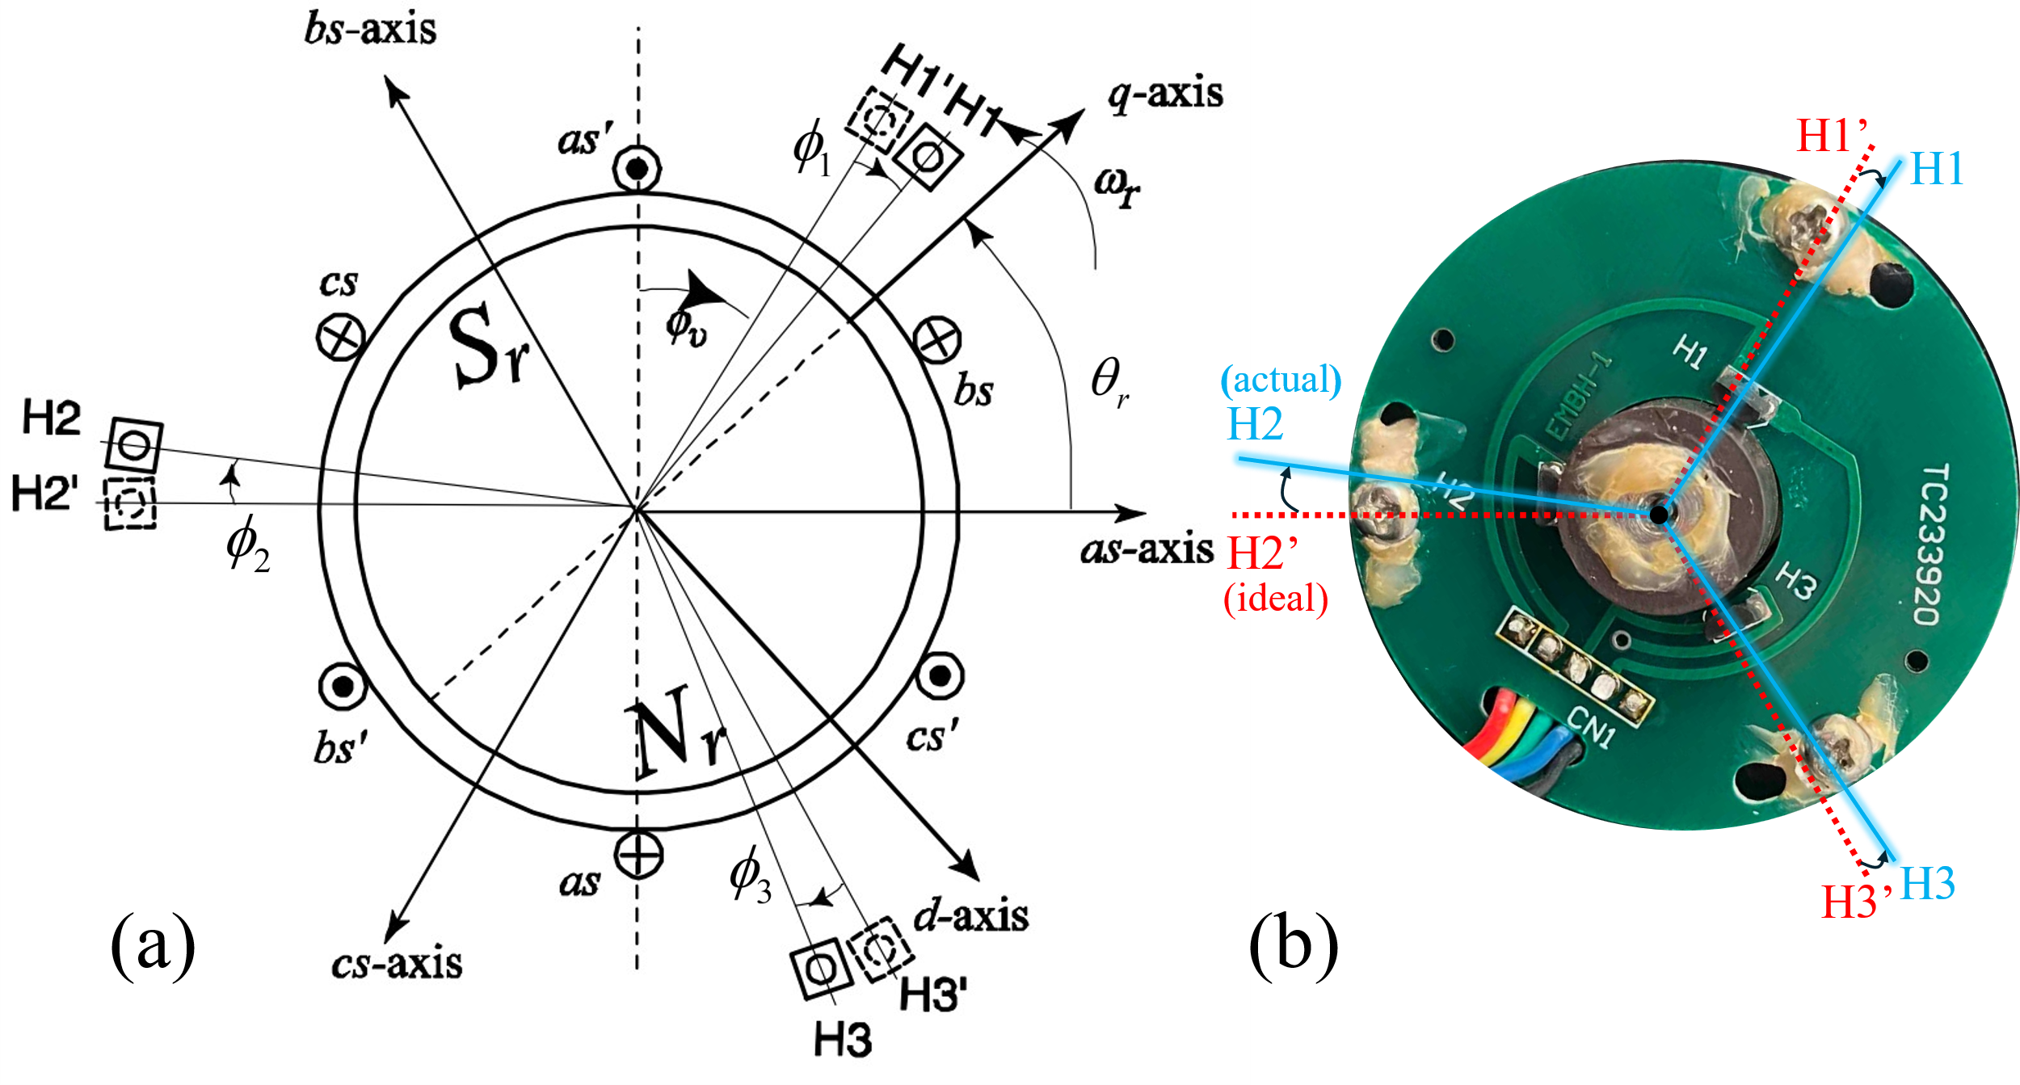

Fig. 4. Misalignment of Hall sensors in a typical BLDC motor.

# Proposed Control Method

## Hall sensor signals Filter via Extrapolated Averaging

This paper builds upon the averaging method proposed in [10] to construct a microcontroller-efficient routine among several proposed Hall-sensor filters. Fig. 5 shows the measured phase current waveforms of the considered BLDC motor operated using 120º commutation logic. Letbe the discrete-value sequence of time intervals between consecutive Hall state transitions, which are marked by a rapid change in phase currents. Due to Hall-sensor misalignment, the discrete sequence  is non-uniform with harmonics [see bottom of Fig. 5]. To balance the intervals, the harmonics can be significantly attenuated using averaging filters of the form [10]

   
The 6-step averaging filter with quadratic extrapolationis selected for the proposed method for its excellent transient response [10], where



The filter is implemented on a microcontroller using interrupt service routines (ISR) and a global timer (details in Section IV). Let  denote the most recent hardware Hall transition time instance. The next scheduled software Hall transition is determined by



where is a correction time to be calculated from the previous time durations [10]. For the filter defined in , the correction time is [10]



## MTPA PI Controller via Compensation of Firing Angle

For BLDC motors with large winding time constant, the optimal MTPA condition can be recovered by adjusting the advance firing anglesuch that the time-averaged *d-*axis currentconverges to zero via a PI controller [7]. Higher output electromagnetic torqueis achieved as the phase currents are phase-aligned with the corresponding back EMFs for the compensated angleThe PI controller scheme is shown on top of Fig. 7, where the *d*-axis current and

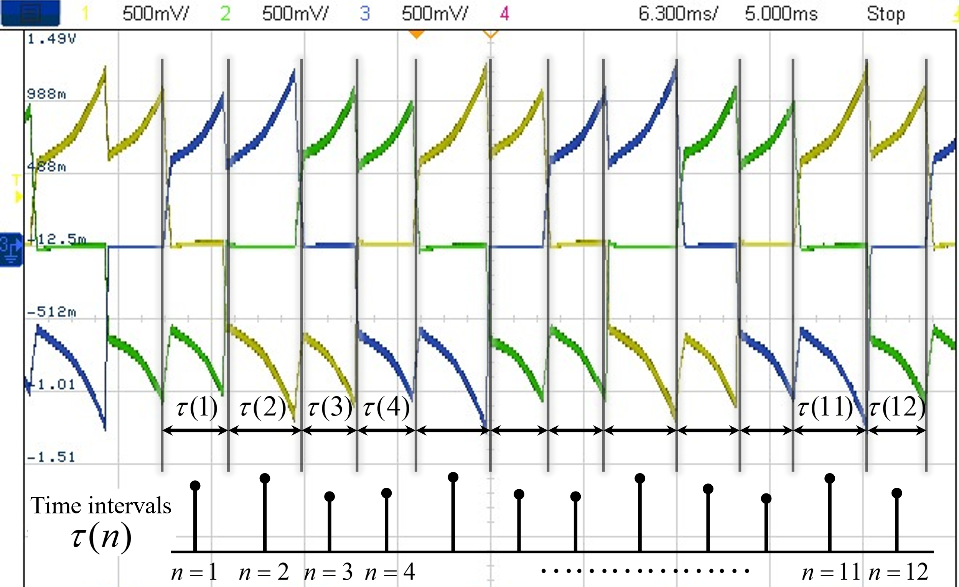

Fig. 5. Switching time intervals distortion due to Hall-sensor misalignment measured on the considered industrial BLDC (see Appendix) in steady-state.

its time-averaged value are computed as





where *T* is the time duration of one electrical cycle and is the estimated electrical speed. In practice, the averaging may be carried out over one switching interval. Together, the Hall-sensor filter and the MTPA controller simultaneously influence the commutation time of the power transistors,

.

Thus, the proposed method can dynamically adjust and achieve the optimal operation in real-time.

# Implementation on Microcontroller

The proposed combined control method has been implemented on Texas Instrument (TI)’s TMDSCNCD28035 C2000TM real-time microcontroller unit (MCU). The MCU is integrated into the TI F28035 control card as part of the DRV8301-HC-EVM VSI development board. However, the algorithm described in this section is readily implementable in any other microcontroller. The motor drive parameters are summarized in the Appendix.

## Implementation of Hall-Sensor Filter

Fig. 6 shows the proposed Hall-sensor filter control algorithm implementation. A recurrent PWM-frequency task (Fig. 6(a)) is used to trigger both the hardware and software interrupt service routines (ISR) to calculate the filter correction time and advance the filtered Hall state, respectively. The hardware ISR (Fig. 6(b)) runs once at every transition of the unfiltered Hall signal. For the convenience of keeping track of the switching intervals, the switching state is defined as [5]

.

This hardware ISR updates the memory of the last six time intervals between Hall state transitions, from which the correction time is calculated to schedule the next software ISR. The scheduled software ISR (Fig. 6(c)) then advances the filtered Hall state.

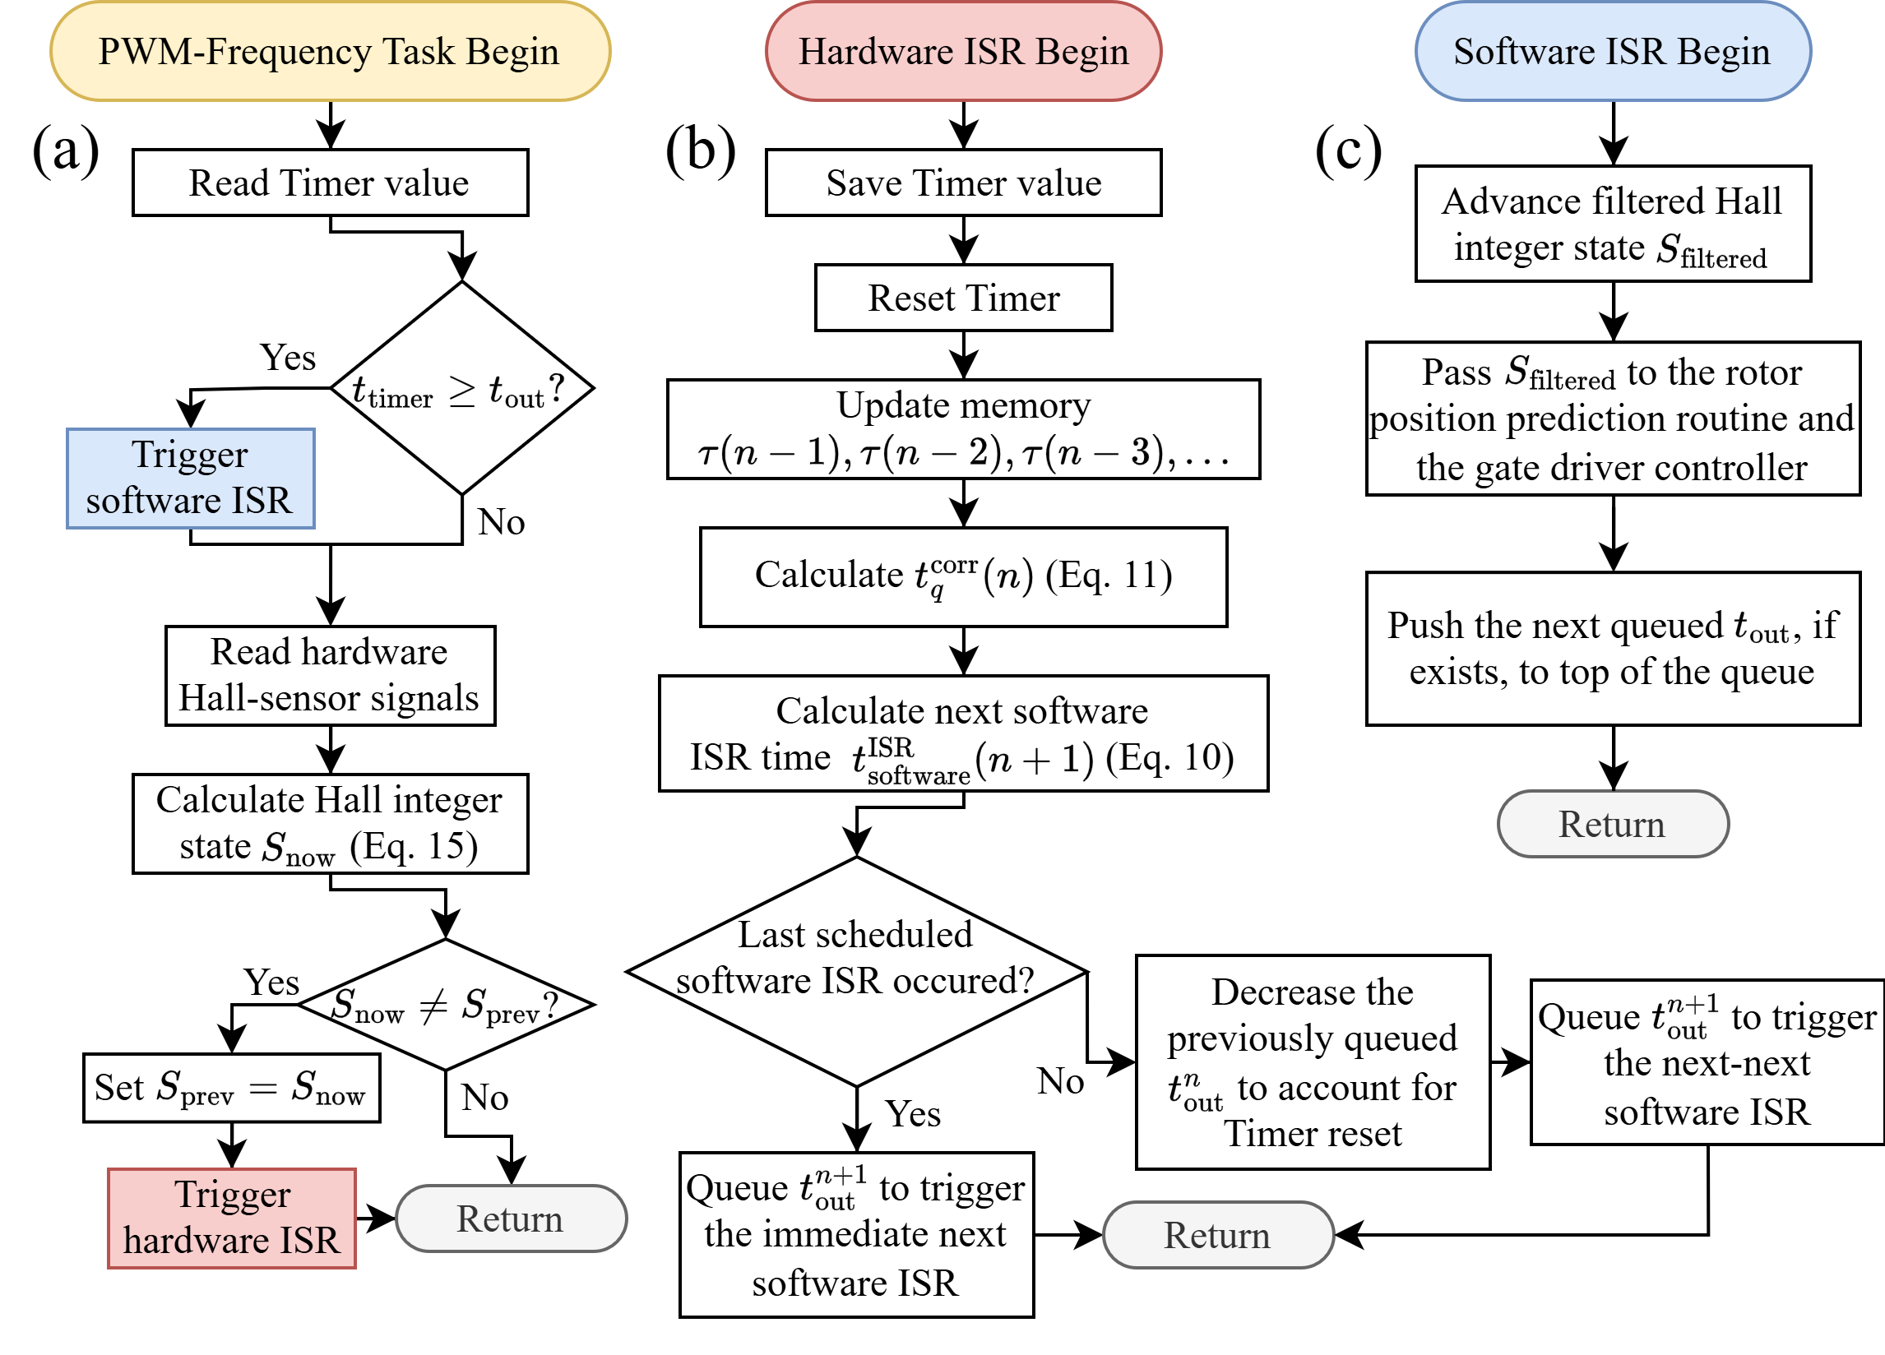

Fig. 6. Flowchart of (a) the PWM-frequency task controlling the hardware and software ISRs, (b) the hardware ISR, and (c) the software ISR to implement the proposed Hall-sensor filtering method on a microcontroller.

Due to Hall-sensor misalignment, some time intervals are longer than others, which implies that the following hardware ISR might be triggered again before the last scheduled software ISR occurs. In this case, the previously scheduled time is decreased to account for resetting the timer, and the new scheduled time is simply queued so as not to overwrite the last untriggered ISR. The PWM-frequency task continuously checks the current timer value to trigger the software ISR (Fig. 6(c)), advancing the filtered Hall state output by one interval. The software ISR should be triggered before the hardware ISR within the PWM-frequency task to reduce complications due to timer resetting.

## Implementation of MTPA PI Controller

After the Hall-sensor filter is enabled to balance the switching intervals, the MTPA PI controller scheme, as shown in Fig. 7(a), is activated to forceby compensating the advance firing angle byThe continuously estimated rotor electrical angle  (required for calculation of  is obtained using linear extrapolation between the filtered Hall state transitions [5]. The microcontroller implementation of the MTPA method is shown in Fig. 7(b). The PWM-frequency task calculates the instantaneoususing and accumulates these values to compute the average at the end of each switching interval. The compensating advance firing angleis updated only once per switching interval. The closed-loop MTPA PI controller parameters are summarized in the Appendix. The Hall-sensor filter routine should be enabled before the MTPA controller, after which both routines are run simultaneously in the same PWM-frequency task to achieve the Hall-sensor filtering and MTPA operation.

# Experimental Results

The proposed combined control method and its microcontroller implementation have been validated experimentally using a typical industrial low-cost BLDC motor

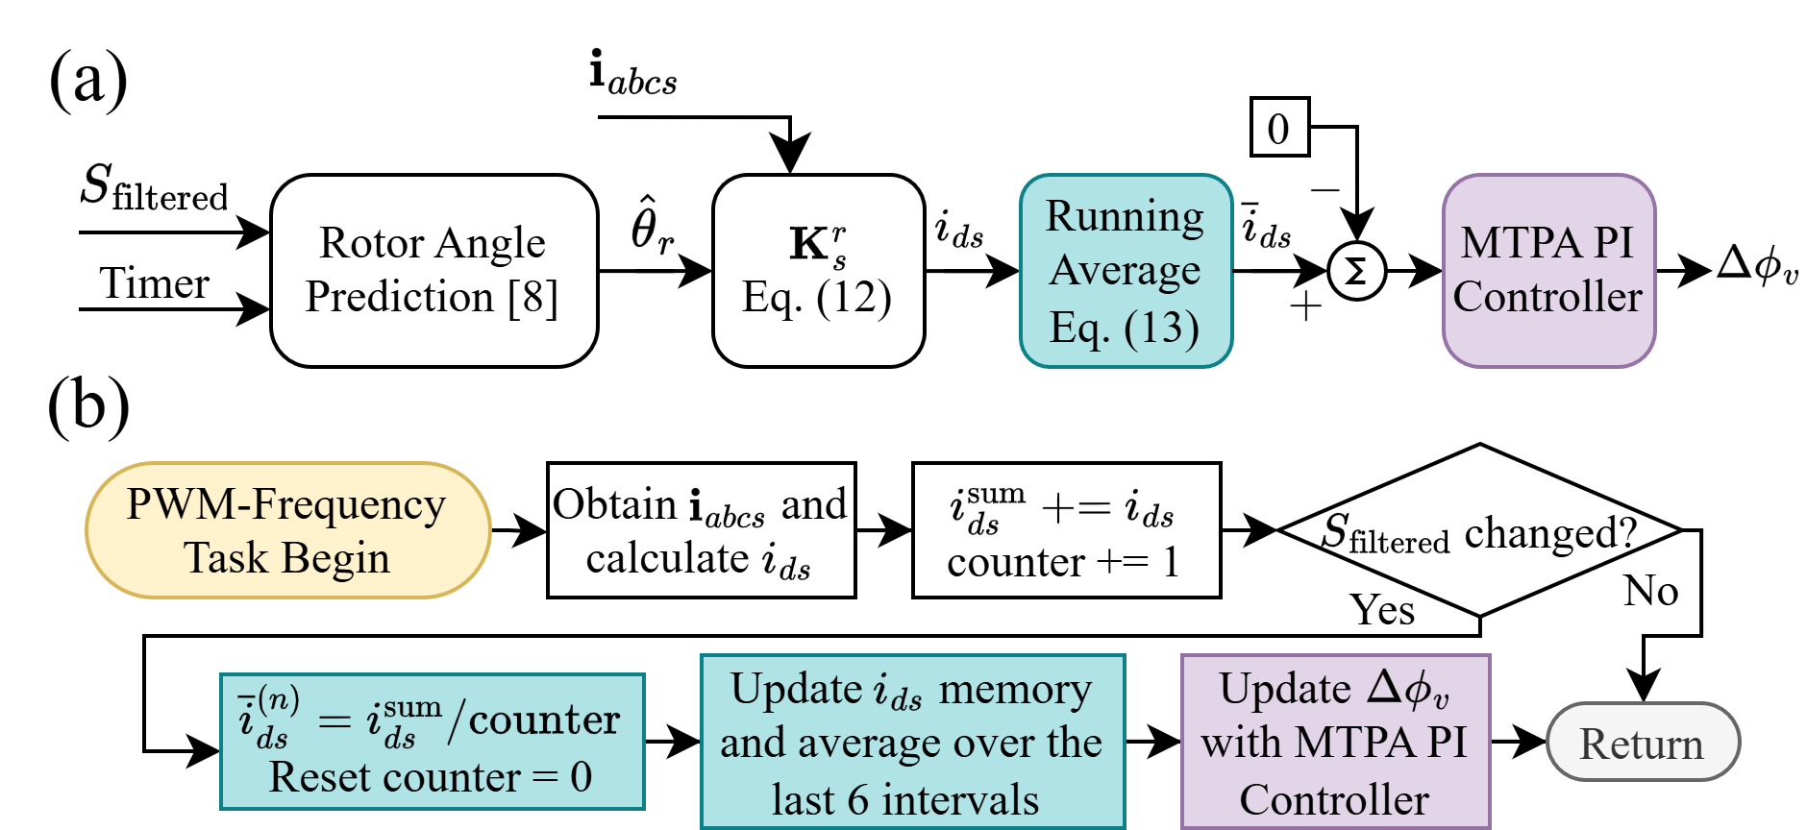

Fig. 7. (a) Flowchart of the proposed MTPA PI controller method and (b) its firmware implementation on a microcontroller (concurrent with Hall filter).

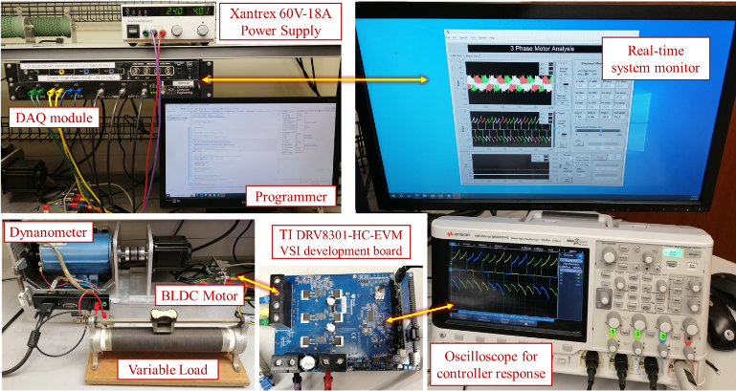

Fig. 8. Experimental BLDC motor drive setup and data acquisition equipment.

with considerable misalignment of Hall sensors and a large stator time constant (motor parameters in the Appendix).

The experimental setup is shown in Fig. 8. The BLDC motor is driven using the DRV8301-HC-EVM development inverter board, which is powered by a DC power supply. The motor operates against a DC dynamometer variable load torque. The phase currents are measured using Micsig 0.1V/A current clamp probes and captured on an oscilloscope. To capture the control response in real-time, the run time variables such as are also output to the Keysight oscilloscope using integrated digital-to-analog converters (DAC) on the TI development inverter board.

Fig. 9 shows the phase current waveforms for the considered motor operating in a steady state at and Nm. Initially (see the left side of Fig. 9(a)), the Hall-sensor misalignment leads to unbalanced time intervalsbetween the Hall state transitions, which leads to distorted phase currents, high torque ripple (and even higher audible noise). After the Hall-sensor filter routine is enabled (see right side of Fig. 9(a)), the time intervals became significantly more balanced, resulting in much more uniform phase currents. The small differences between the peaks of currents may be attributed to the motor shaft and the dynamometer coupler.

The condition is now ready to enable the MTPA PI controller (see the left side of Fig. 9(b)). After the MTPA controller is enabled, the balanced time intervals  are not compromised. At the same time, the peaks of the phase currents are noticeably reduced, suggesting that higher efficiency is achieved at the same torque operating point.

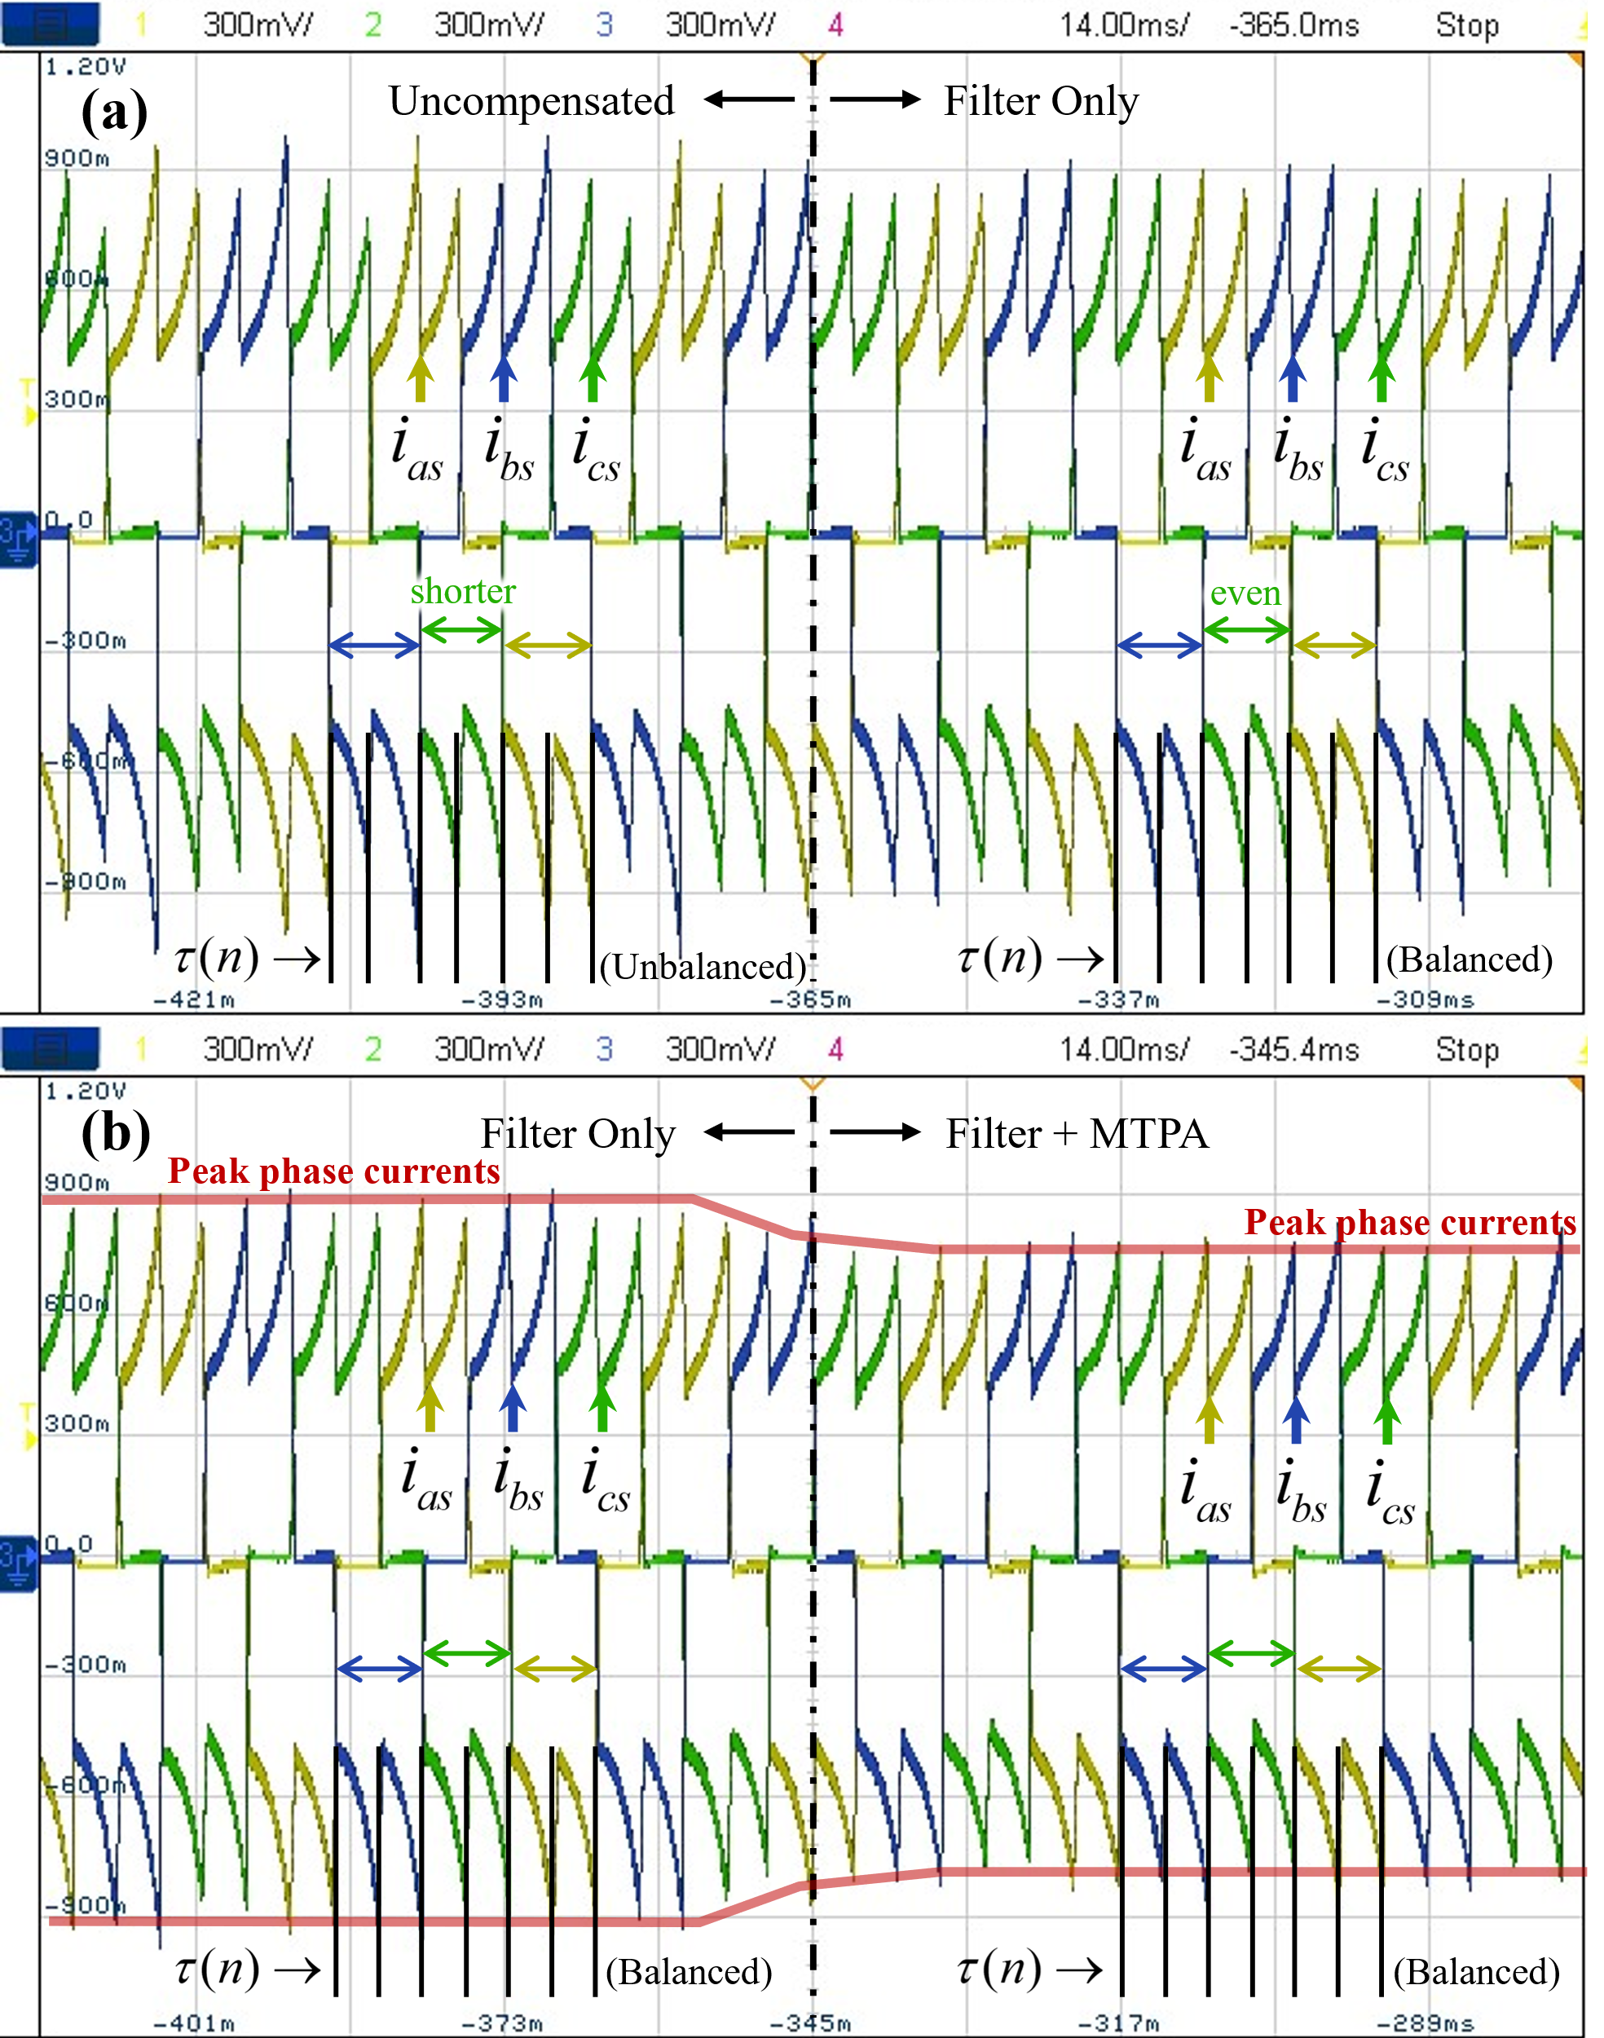

Fig. 9. Measured phase current waveforms observed on an oscilloscope: (a) moment of enabling filtering of Hall sensor signals, and (b) activation of MTPA PI controller

To validate the MTPA condition, Fig. 10 shows the responses of the phase current average *d-*axis currentand the compensation advance firing angle at the moment of MTPA PI controller enabling time for small (see Fig. 10(a)) and nominal (see Fig. 10(b)) output electromagnetic torque. In both cases, when the proposed MTPA controller is enabled, rapidly converges to zero over a few switching intervals andalso converges to the optimal value to achieve MTPA. The finalvalues are different for the two different operating points, indicating that the proposed method can dynamically achieve MTPA in real-time under various conditions. Indeed, the peak phase current decreases considerably when the MTPA controller is enabled for the same output torque 

After the initial enabling sequence, the Hall-sensor filter and the MTPA PI controller operate simultaneously. In particular,should be maintained by dynamically updatingunder changing operating conditions. Fig. 11 shows a transient response of the system under the step-up and step-down changes of output torque between 0.51 Nm and 1 Nm (by changing the duty cycle for a fixed load and fixed  During step-up torque transient (see Fig. 11(a)), increases rapidly from 7.08° to 11.34° over a few switching intervals. This is consistent with the longer current commutation time at higher torque, which worsens the phase shift between the phase current and back EMF. Despite small fluctuations during the transient, is sustained before and after the change. Similarly, during the step-down transient (see Fig. 11(b)),

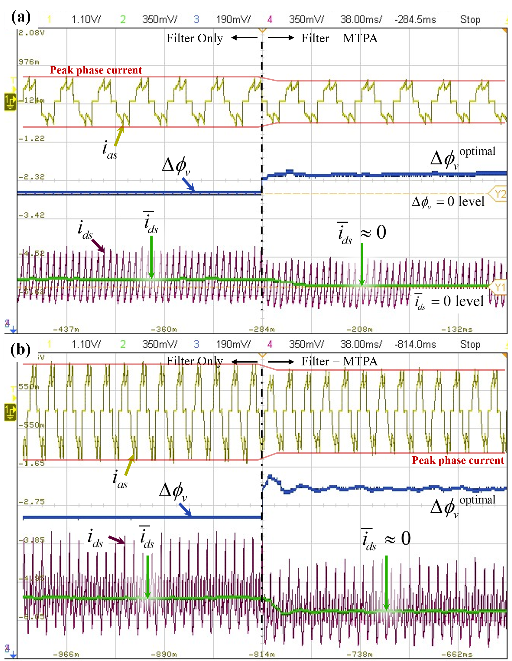

Fig. 10. Responses of phase current*d-*axis currentandand the compensating advance firing angleat the MTPA PI controller enabling time for the considered BLDC motor at: (a) operating point defined by, and (b) operating point defined by  .

returns to the initial value of 7.08° and the MTPA operation is sustained. This experiment shows that the proposed combined method operates dynamically and stably to achieve MTPA with a very fast response to changes in operating point.

Finally, a sweep of the torque-per-Ampere ratio, defined asfor the BLDC motor drive with enabled Hall sensor filter routine and with/without the MTPA PI controller over a wide range of output electromagnetic torque is shown in Fig. 12. The compensating angle is also plotted in Fig. 12 (with the vertical axis on the right side). As seen in Fig. 12, at every output torque value, the torque-per-Ampere ratio is higher when the MTPA PI controller is enabled compared to a common operating mode (COM) that just uses the Hall signals. As torque and current magnitude increase, the current commutation time also increases, requiring a larger compensation of advance firing angle At larger torques, thebecomes more significant (up to 15°) and an increasing improvement over the COM can be expected. The results in Fig. 12 show that the torque-per-Ampere improvement of using the proposed MTPA controller increases with increasing torque. This demonstrates that the proposed combined method can accurately adjust the firing angle  to achieve MTPA for BLDC motors with Hall-sensor misalignment and large winding inductance over a wide range of operating conditions.

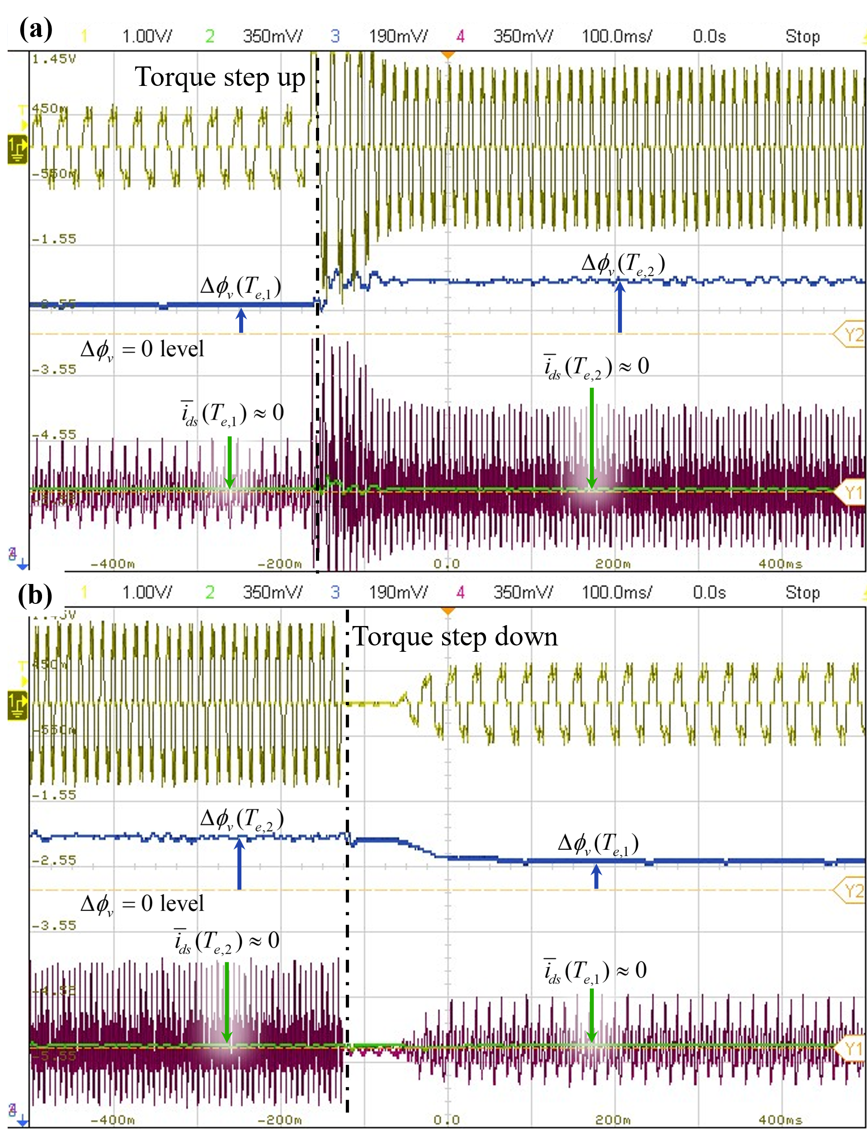

Fig. 11. Responses of phase current*d-*axis currentandand the compensating advance firing angleunder output electromagnetic torque step up and step down transients withand

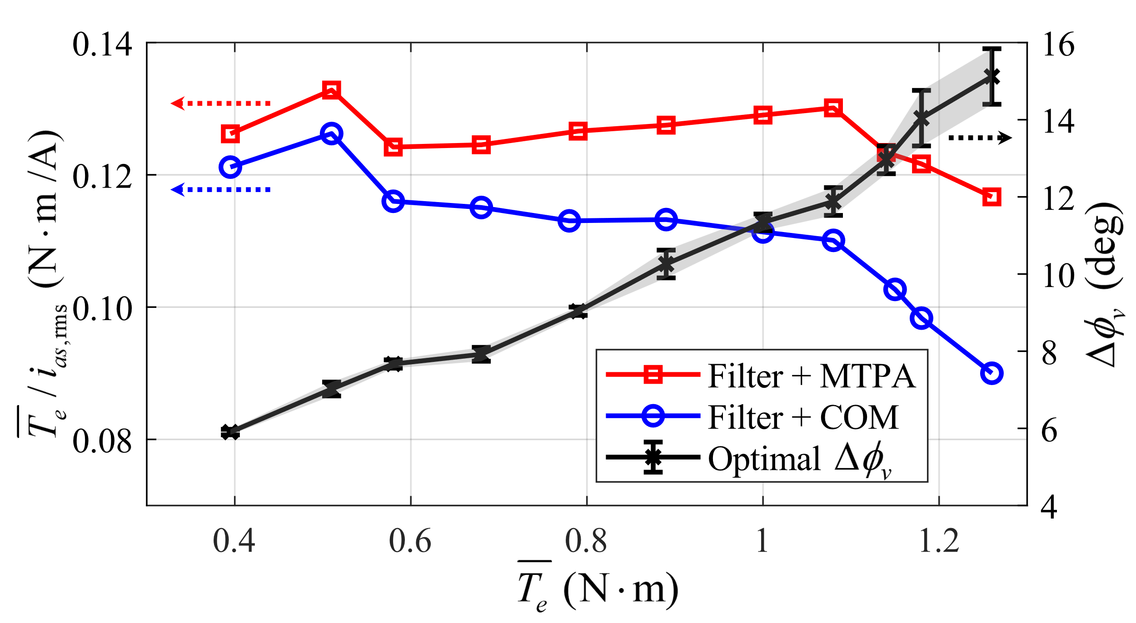

Fig. 12. Torque-per-Ampere ratio and compensating advance firing angleto achieve MTPA for different values of output torque

# Conclusion

This paper aims to simultaneously solve the challenges of achieving MTPA operation for very common low-cost industrial BLDC motors with Hall-sensor misalignment and large winding inductance. The proposed method is developed assuming the most commonly used six-step 120° commutation. When using the previously developed Hall-sensor filtering alone, the mismatch between the fundamental component of the phase current and the corresponding back EMF increases, deviating from optimal MTPA condition. At the same time, using an MTPA controller without effective Hall-sensor filtering leads to oscillations in the firing angle compensation due to the unbalanced switching intervals. To address both problems, a control method integrating the Hall-sensor filtering and the MTPA PI controller is proposed.

The detailed implementation of the proposed combined method on a microcontroller is validated with experiments on a typical industrial BLDC motor with significant misalignment of Hall sensors and large stator winding inductance. The proposed method successfully mitigates errors in Hall sensor signals while achieving MTPA operation over a wide range of operating conditions and transients. Future research will investigate the dynamic tuning of the MTPA PI controller based on speed to optimize the firing angle response and implement a look-up-table-based Hall-sensor filter to improve torque-speed response during significant transients.

##### Appendix

*A) BLDC parameters*: Arrow Precision Motor Company, Ltd., Model 86EMB3S98F, 36V, 2000 r/min, 8 poles, ,,, 

*Estimated Hall-sensor misalignment*: 

*MTPA PI controller parameters:* 

*B) Microcontroller:* DRV8301-HC-EVM VSI development board with TI F28035 control card (TI C2000TM MCU series).

*Measurement equipment*: oscilloscope Keysight DSOX2004A, current clamps probes Micsig CP503B 0.1V/A, differential voltage probes Micsig DP10007 100MHz.

##### References

1. A. Ghayth and M. Şimşir, “Recent Trends and Challenges of Electric Motor Technologies,”  *Int. J. Electr. Eng. and Sustain.*, vol. 1, no. 2, pp. 21–28, Nov. 2023.
2. P. C. Krause, Oleg Wasynczuk, S. Pekarek, and T. O’Connell, *Electromechanical Motion Devices: Rotating Magnetic field-based Analysis with Online Animations*. Hoboken: Wiley-Ieee Press, 2020.
3. D. Mohanraj *et al.*, “A Review of BLDC Motor: State of Art, Advanced Control Techniques, and Applications,” *IEEE Access*, vol. 10, pp. 54833–54869, 2022.
4. S. D. Sudhoff and P. C. Krause, “Operating modes of the brushless DC motor with a 120 degrees inverter,” *IEEE Transactions on Energy Conversion*, vol. 5, no. 3, pp. 558–564, 1990.
5. J. Zhou, S. Ebrahimi, and J. Jatskevich, “Extended Operation of Brushless DC Motors Beyond 120° under Maximum Torque Per Ampere Control,” *IEEE Transactions on Energy Conversion*, vol. 38, no. 2, pp. 1–12, 2023.
6. P. Alaeinovin, S. Chiniforoosh, and J. Jatskevich, "Evaluating misalignment of hall sensors in brushless DC motors," in *Proc. IEEE Canada Electric Power Conf.*, Oct. 2008, pp. 1–6.
7. J. Zhou, J. Lu, S. Ebrahimi, and J. Jatskevich, “A Compensation of Commutation Angle in Hall-Sensor-Controlled Brushless DC Motors for Maximum Torque per Ampere Operation,” *2022 21st International Symposium INFOTEH-JAHORINA (INFOTEH)*, pp. 1–6, Mar. 2022.
8. F. Ghavamirad and A. Rezazadeh, “Investigating the effect of Hall effect sensor position error on BLDC motor torque,” *International Journal of Electric and Hybrid Vehicles*, vol. 16, no. 4, pp. 358–373, Jan. 2024.
9. N. Samoylenko, Q. Han, and J. Jatskevich, “Balancing Hall-Effect Signals in Low-Precision Brushless DC Motors,” *APEC 07 - Twenty-Second Annual IEEE Applied Power Electronics Conference and Exposition*, pp. 606–611, Feb. 2007.
10. N. Samoylenko, Q. Han, and J. Jatskevich, “Dynamic Performance of Brushless DC Motors With Unbalanced Hall Sensors,” *IEEE Transactions on Energy Conversion*, vol. 23, no. 3, pp. 752–763, Sep. 2008.
11. B. Tan, X. Wang, D. Zhao, K. Shen, J. Zhao, and X. Ding, “A Lag Angle Compensation Strategy of Phase Current for High-Speed BLDC Motors,” *IEEE Access*, vol. 7, pp. 9566–9574, 2019.
12. X. Shi, X. Wang, C. Gu, and Z. Deng, “A novel commutation correction method for high-speed PM brushless dc motor,” *2022 IEEE Applied Power Electronics Conference and Exposition (APEC)*, pp. 1899–1905, Mar. 2017.